Task One:

- Entities of the University:
Student (Strong Entity)
- StudentID (Primary), Name, DateOfBirth, Gender, Address, PhoneNumber, Email, Status, AcademicYear, AcademicLevel, StudentNumber, PaidFees, DepartmentID (Foreign).

Course (Strong Entity)
- CourseID (Primary), CourseName, Requirements, AcademicLevel, AcademicYear, DepartmentID (Foreign).

Lecturer (Strong Entity)
- LecturerID (Primary), LecturerName, Email, PhoneNumber, DaysOff, CourseID (Foreign), DepartmentID (Foreign).

Department (Strong Entity)
- DepartmentID (Primary), DepartmentName, DepartmentCode, Grade.

Enrolment (Weak Entity)
- EnrolmentID (Primary), Grade, StudentID (Foreign), CourseID (Foreign).

ExamResult (Weak Entity)
- ResultID (Primary), ExamDate, Total, StudentID (Foreign), CourseID (Foreign).

OpeningTimes (Weak Entity)
- OpenTimesID (Primary), DayOfWeek, OpenTime, CloseTime, Location, DepartmentID (Foreign).

UniversityInfo
- UniversityID (Primary), UnversityName, Address, PhoneNumber.

- Each Relation Needs:
Student: Students enrolled into the university, includes their academic and personal information.

Course: Courses offered by the university at with many levels.

Lecturer: Lecturer in which course they teach.

Department: Departments within the university, e.g School of Computing, School of Business etc.

Enrolment: Relationship within the students and university in which student is enrolled in which course along with their grades.

ExamResult: The results of the exams for each individual student in whatever course they’ve taken.

OpeningTimes: The different opening times for each department.

UniversityInfo: Information on the university which is under all the entities.

- Relationship with each Entity:
Student - Enrolment: One to Many. (A student needs to enroll to a course to be able to attend).
Purpose: Total (Every student must enroll in at least one course).

Course – Enrolment: One to Many. (A course can have multiple students enrolled, but each enrolment record is for one course).
Purpose: Total (Every course must have at least one student enrolled).

Lecturer – Course: One-to-Many (A Lecturer can teach multiple courses, but each course is taught by one Lecturer).Purpose: Partial (Not all lecturers teach courses at the same time).

Department – Course: One-to-Many (A department can offer multiple courses, but each course belongs to one department).
Purpose: Total (Every course must belong to a department).

Department – Lecturer: One-to-Many (A department can have multiple instructors, but each instructor belongs to one department).
Purpose: Total (Every instructor must belong to a department).

Student – ExamResult: One-to-Many (A student can have multiple exam results, but each exam result is for one student).
Purpose: Total (Every student must receive whatever exam result is present in the course).

Course – ExamResult: One-to-Many (A course can have multiple exam results, but each exam result is for one course).
Purpose: Total (Every course must have at least one exam result).

Department – OpeningTimes: One-to-One (Each department has one set of opening times).
Purpose: Total (Every department must have opening times).

UniversityInfo: No Relationship as it has only the basic information. Purpose: Total (Just basic contacts and information of the university).
4.Conceptual Level ER Diagram:
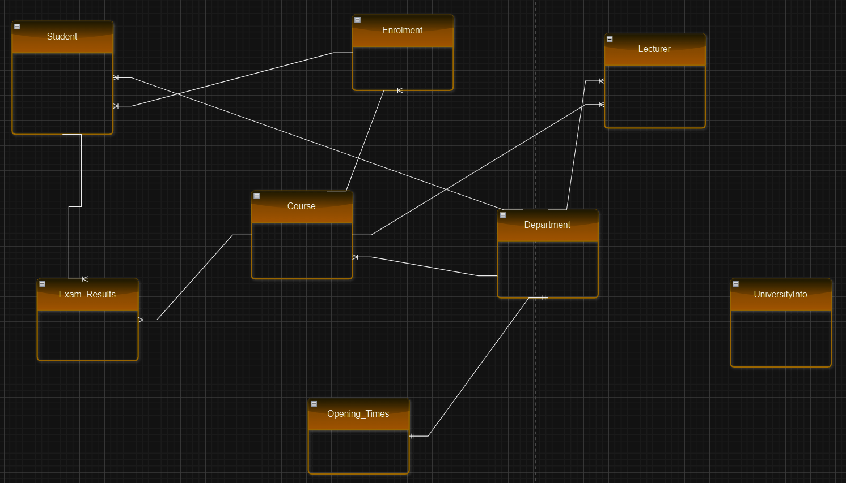

5.Logical Dataset:
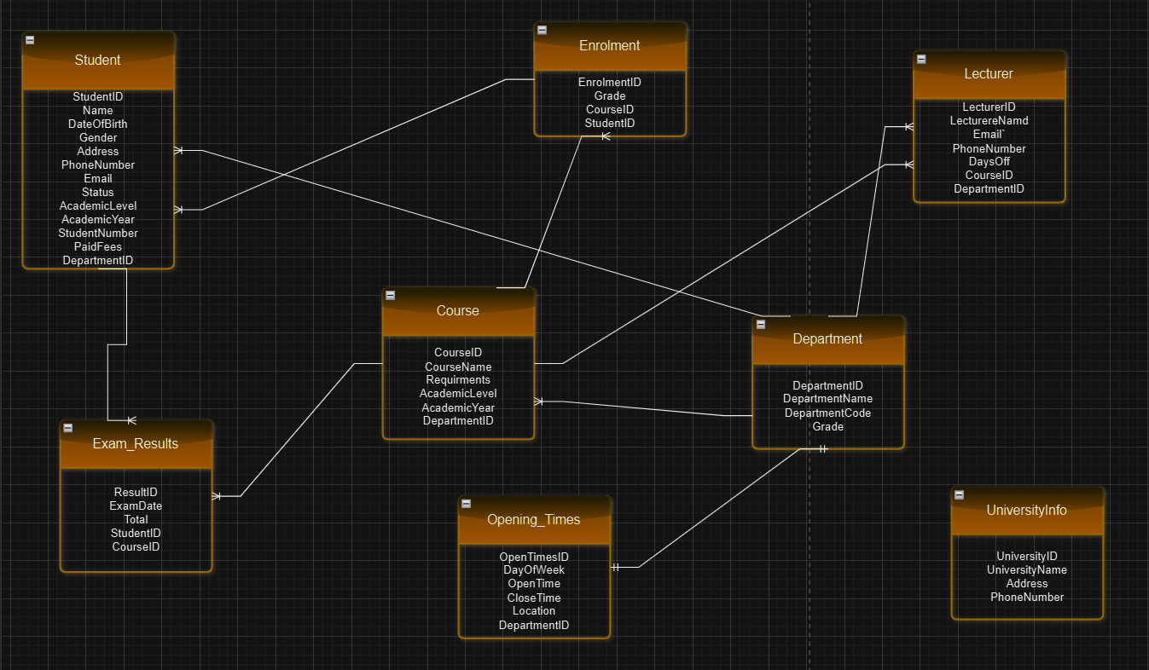

6. Physical Level ERD:
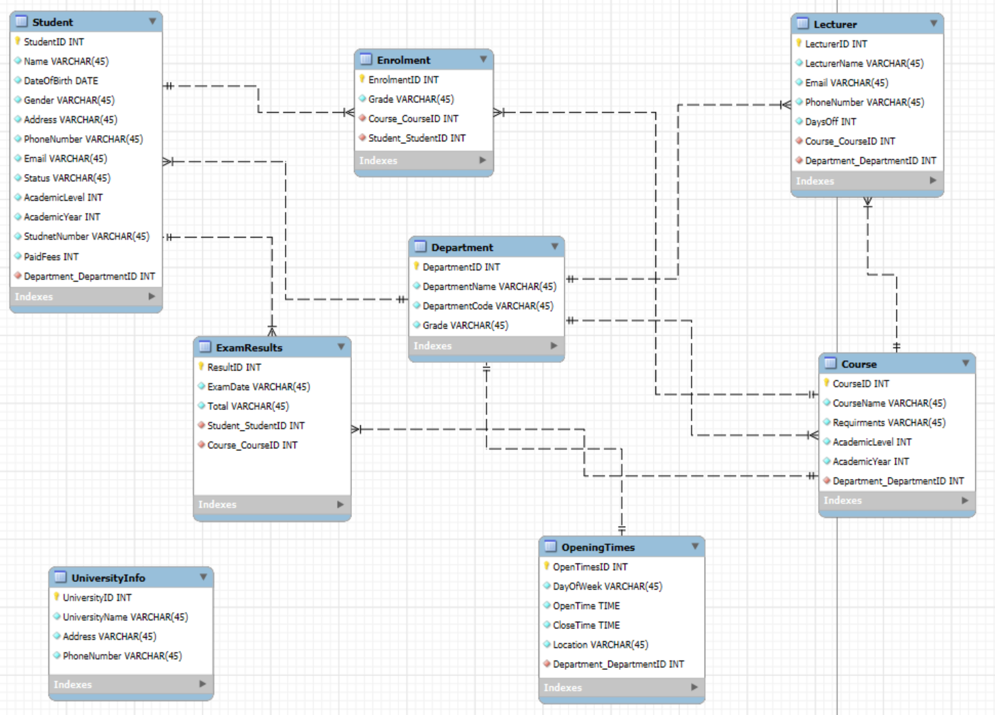
7.Relational Model
Student:
- StudentID (PK), Name, DateOfBirth, Gender, Address, PhoneNumber, Email, Status, AcademicYear, AcademicLevel, StudentNumber, PaidFees, DepartmentID (FK).

Course:
- CourseID (PK), CourseName, Requirements, AcademicLevel, AcademicYear, DepartmentID (FK).

Lecturer:
- LecturerID (PK), LecturerName, Email, PhoneNumber, DaysOff, CourseID (FK), DepartmentID (FK).

Department:
- DepartmentID (PK), DepartmentName, DepartmentCode, Grade.

Enrolment:
- EnrolmentID (PK), Grade, StudentID (FK), CourseID (FK).

ExamResult:
- ResultID (PK), ExamDate, Total, StudentID (FK), CourseID (FK).

OpeningTimes:
- OpenTimesID (PK), DayOfWeek, OpenTime, CloseTime, Location, DepartmentID (FK).

UniversityInfo
- UniversityID (PK), UnversityName, Address, PhoneNumber.

Task Two Tables/Data:
All My tables and data that I used.
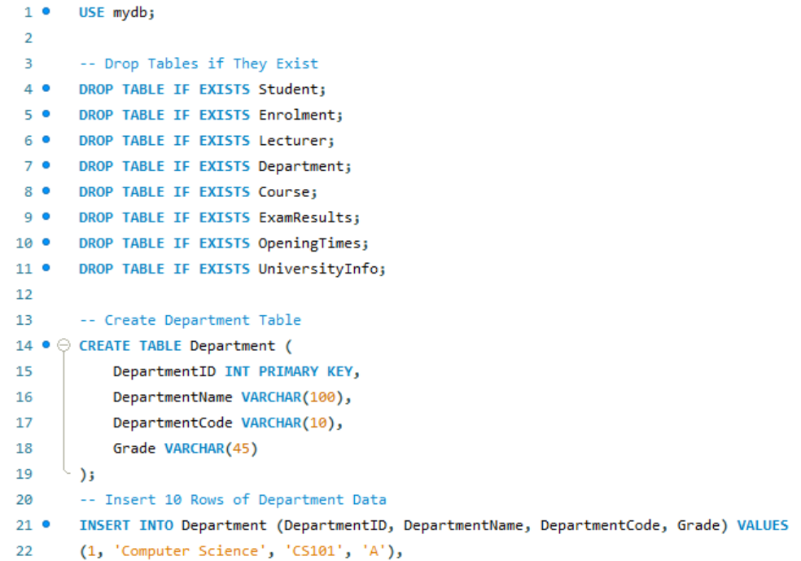
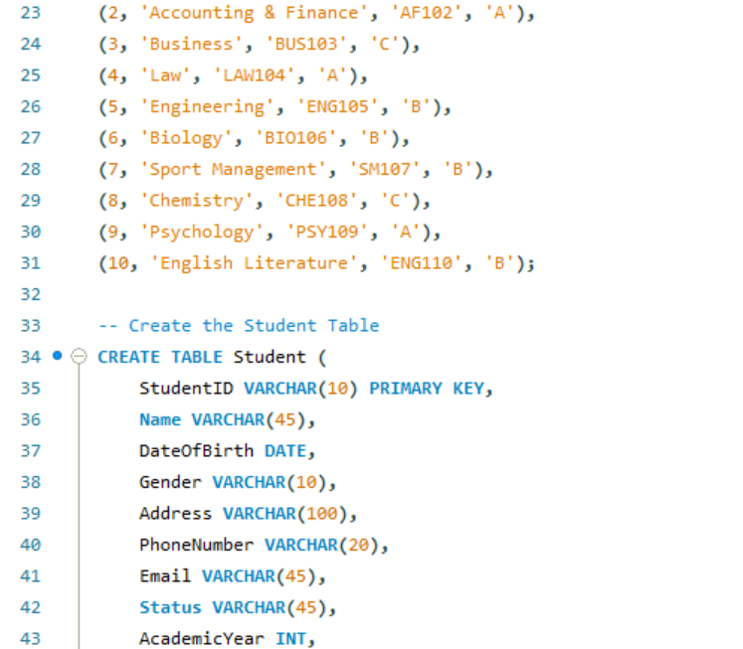
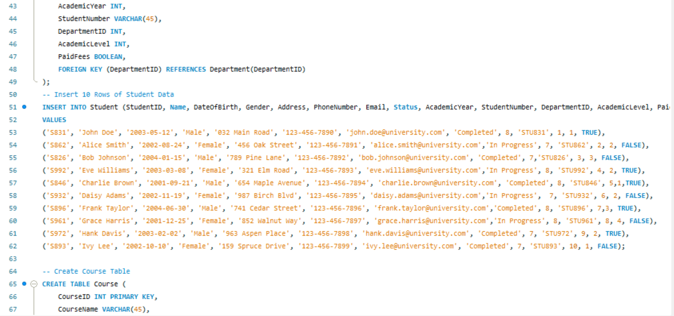

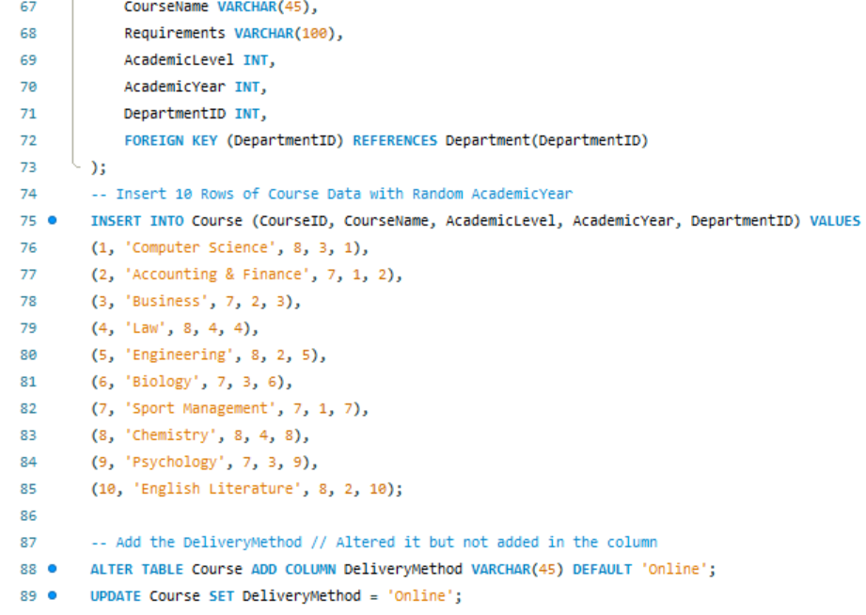
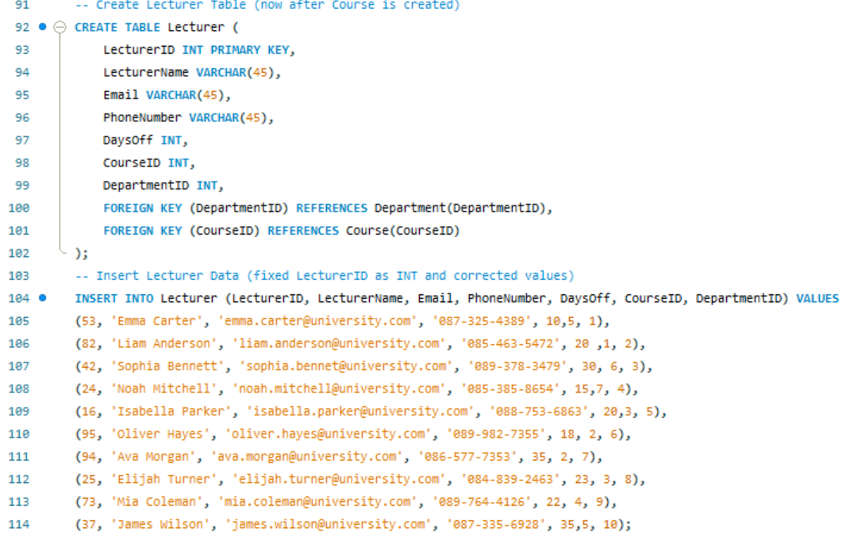
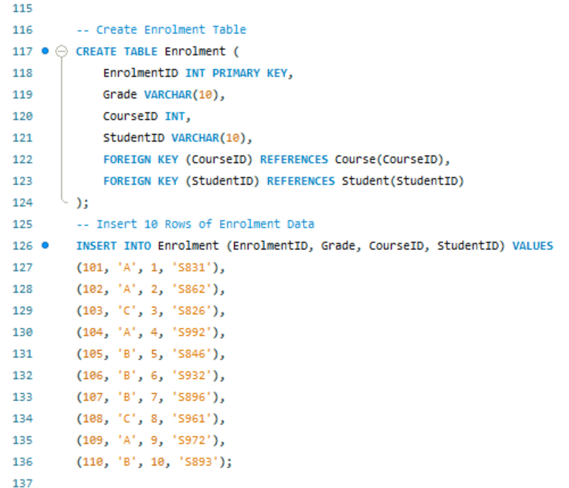
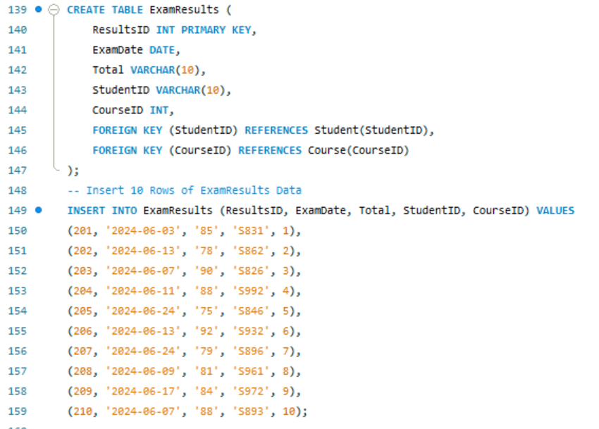
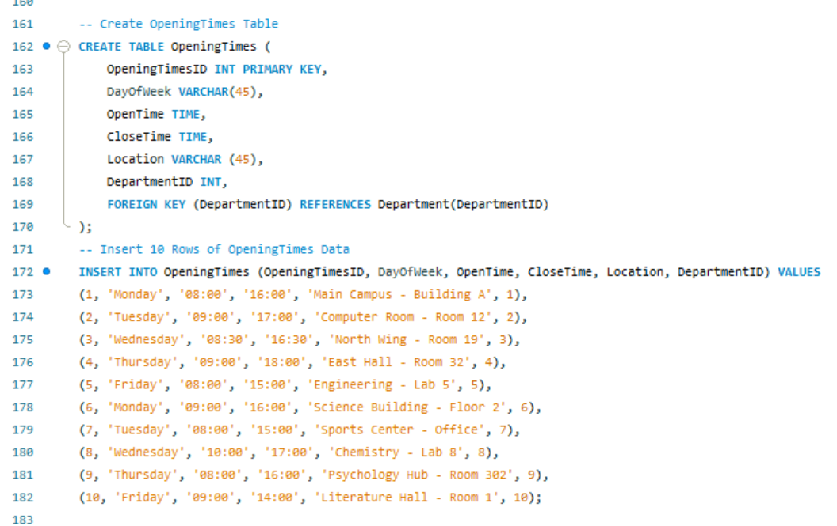
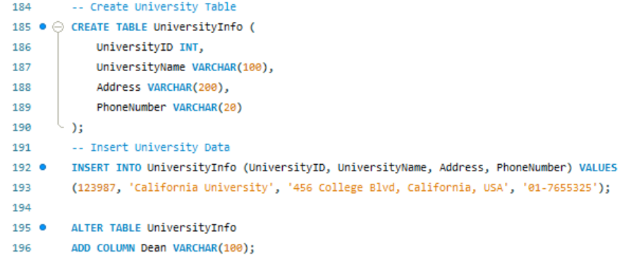

Task Three 1 - 20:
Task 3 - 1.
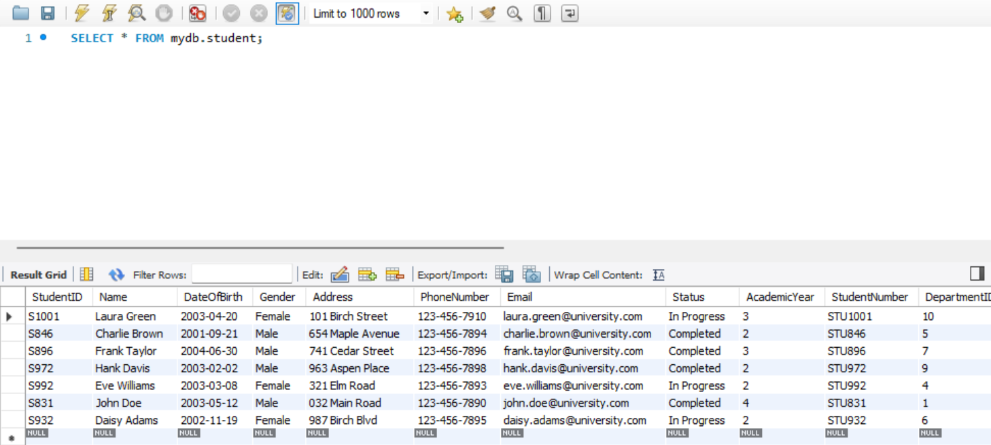
Task 3 - 2.
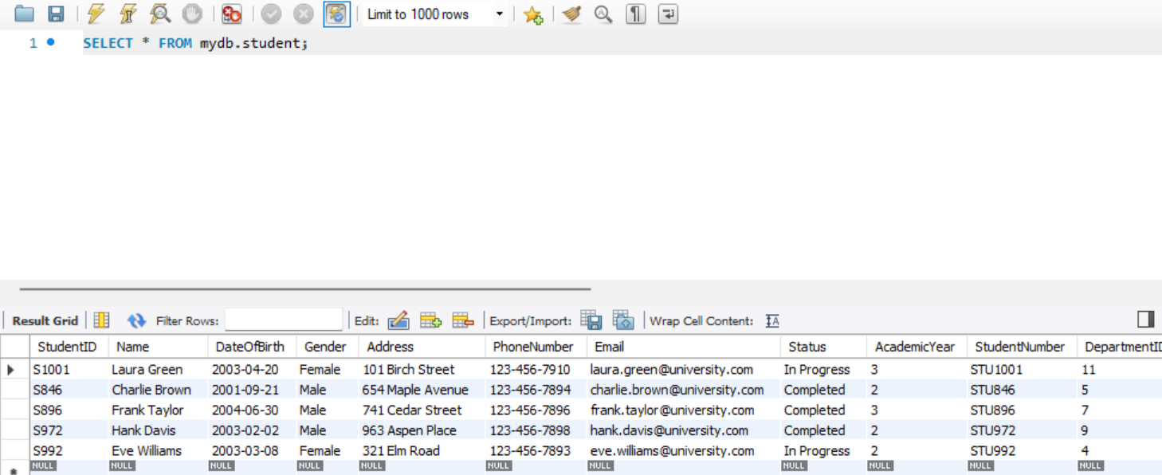
Task 3 - 3.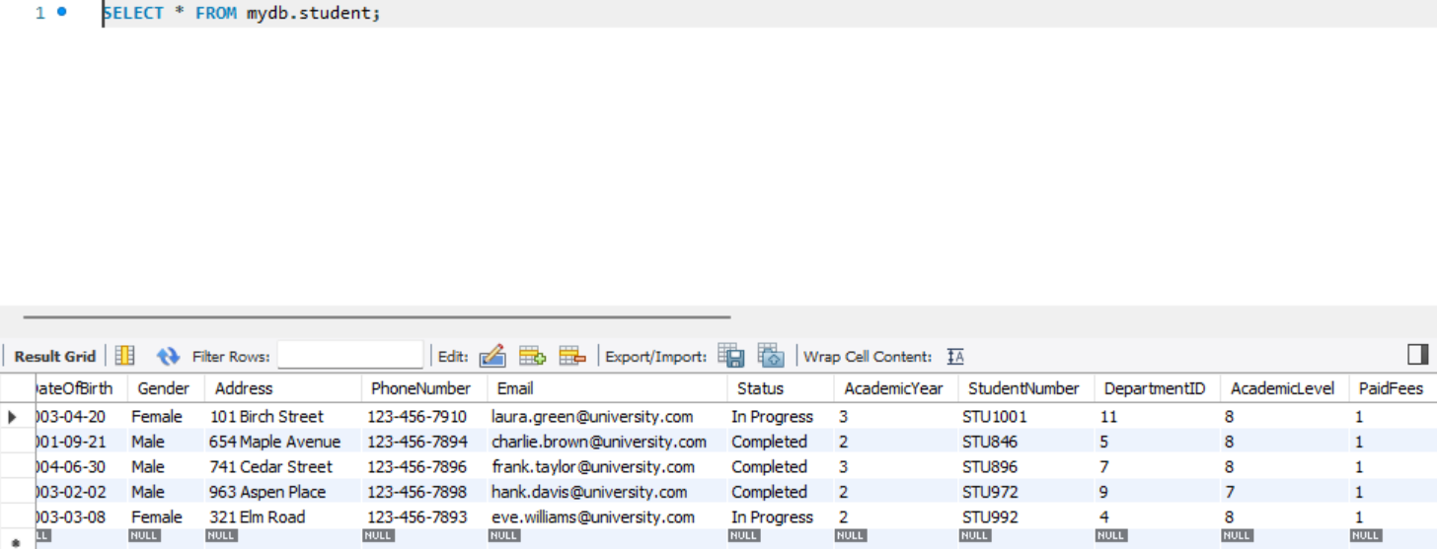
Task 3 - 4.
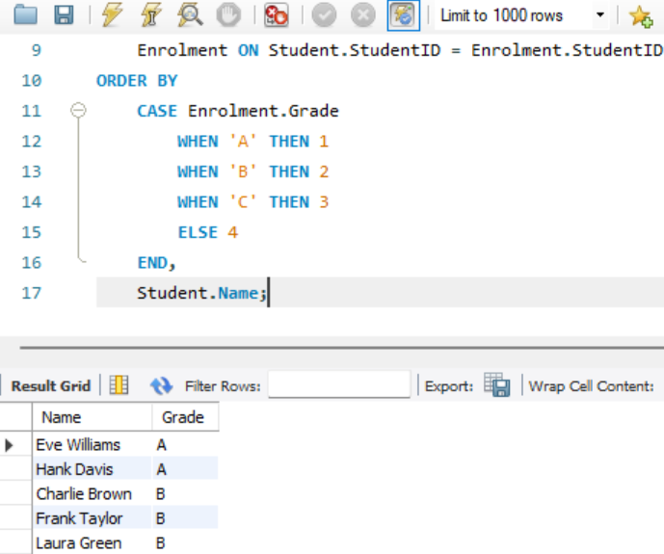
Task 3 - 5.
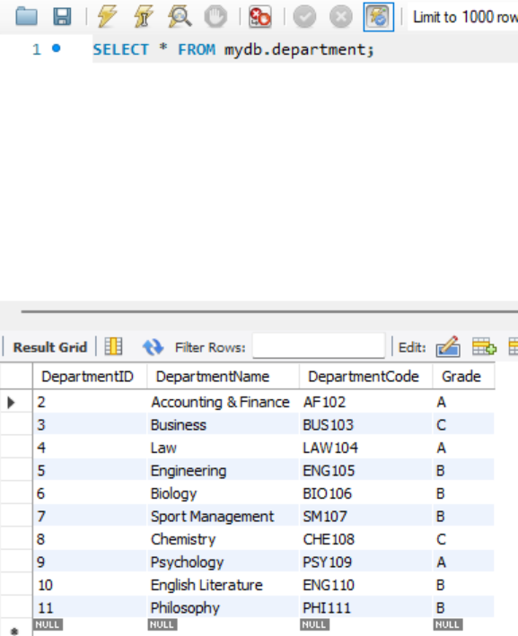
Task 3 - 6.
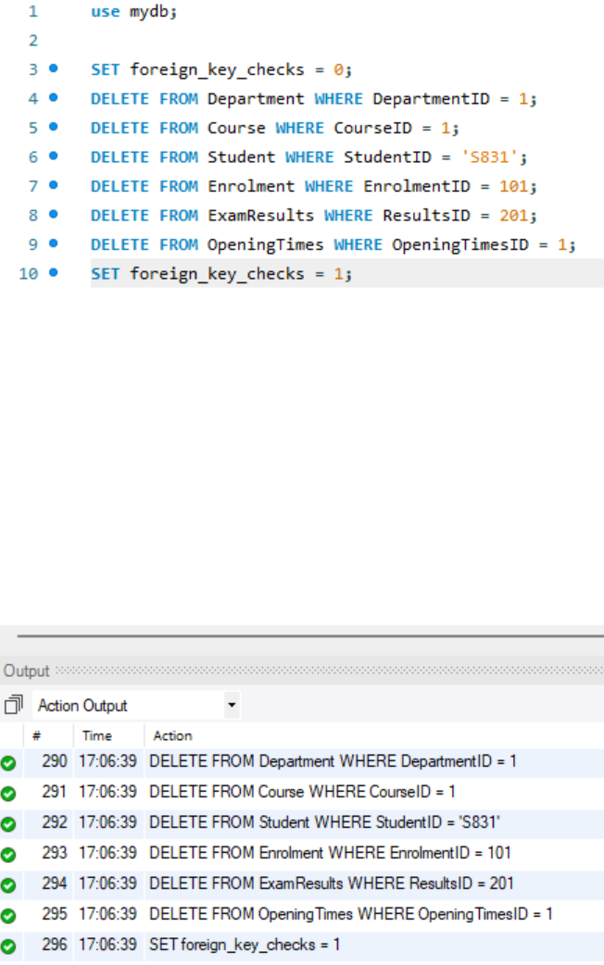

Task 3 - 7.
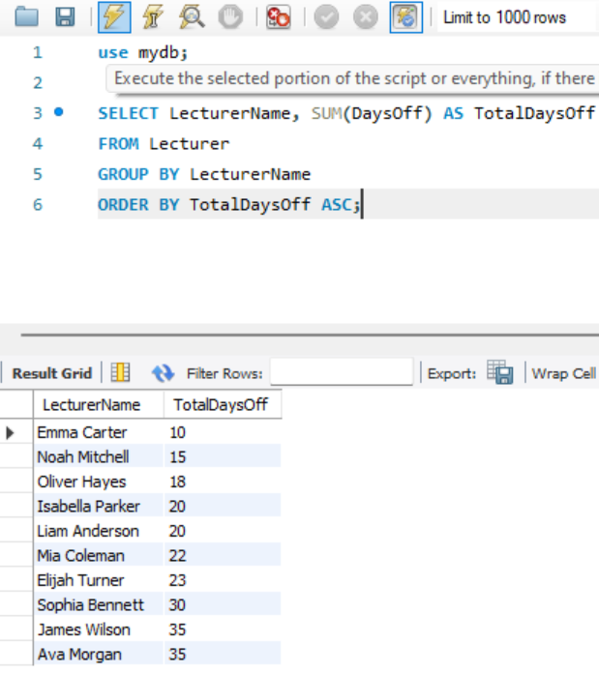
Task 3 - 8.
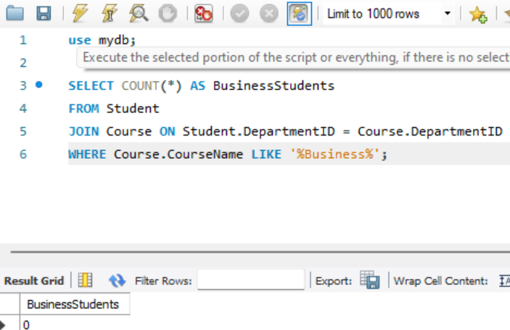

Task 3 - 9.
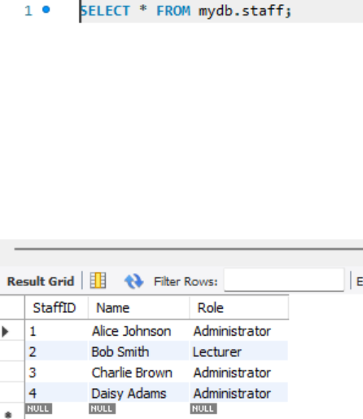
Task 3 - 10.
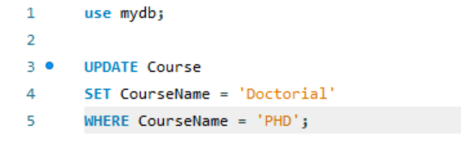

Task 3 - 11.
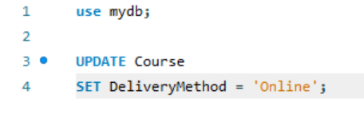
Task 3 - 12.
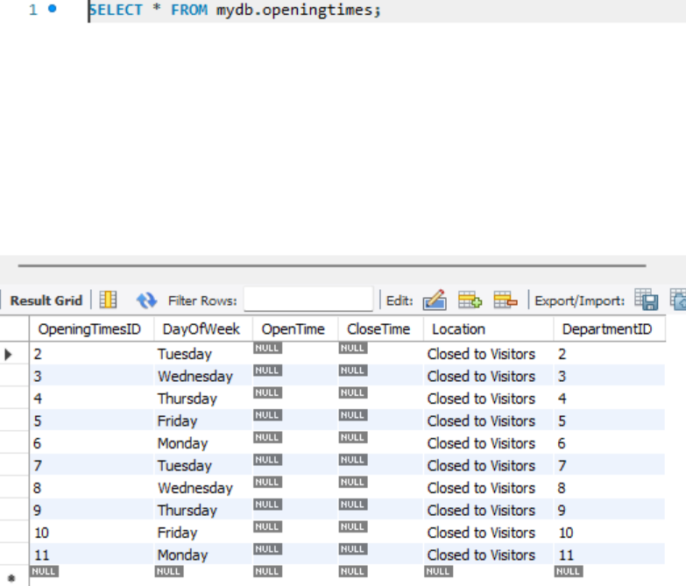

Task 3 - 13.
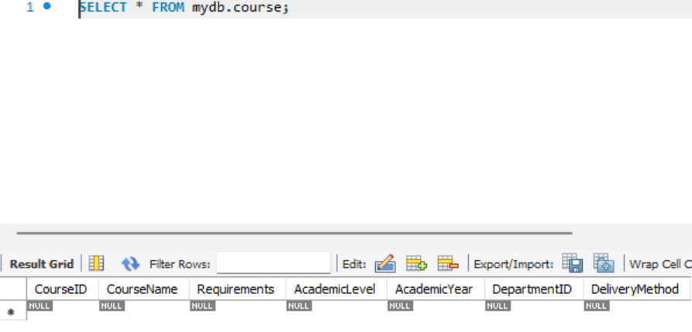
Task 3 - 14.
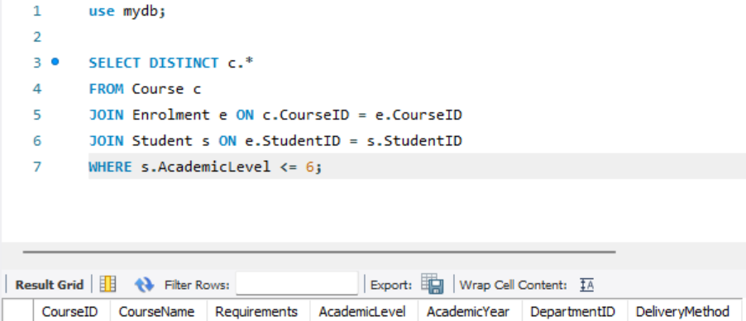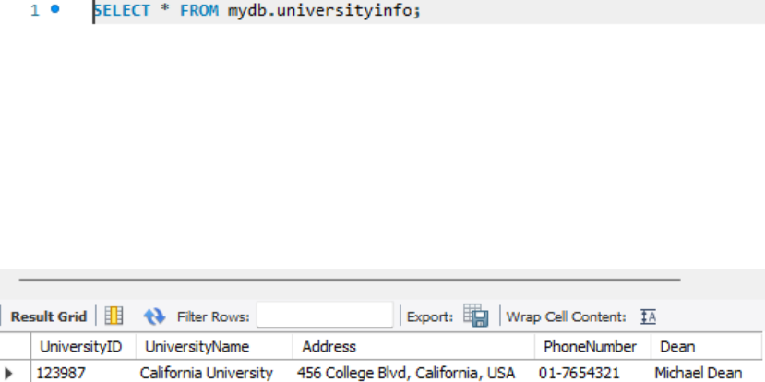
Task 3 - 15.
Task 3 - 16.
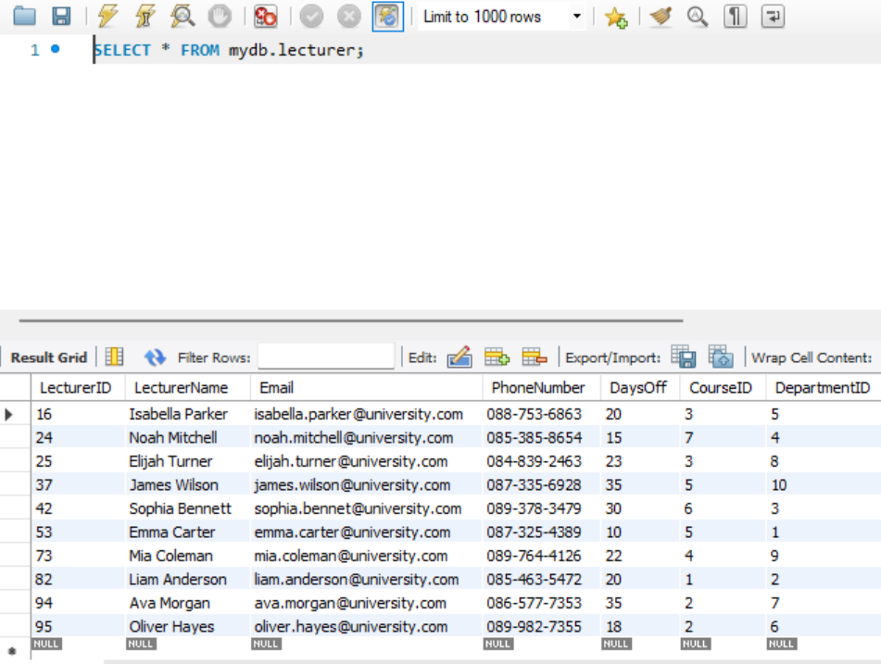

Task 3 - 17.
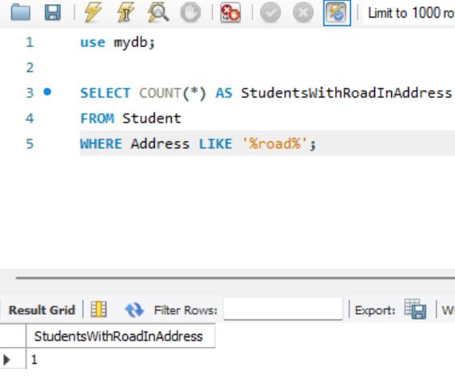
Task 3 - 19.
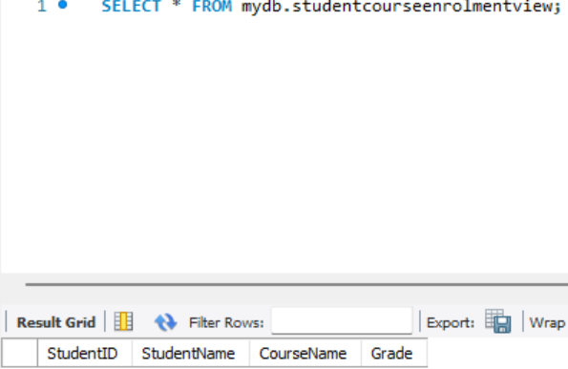
These are the outputs for each task I’ve done but the code doesn’t fully show along with the output. For some questions the output doesn’t work so I just screenshot the command for the output.

When it is supposed to show 10 rows of students for example it will not show but my insert tables and data for them work. I didn’t attempt Task 3 – 18 and my question 20 has an error which you can only see when you run the full data and tables SQL. But my data and tables to insert are functional.

